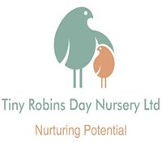
Health and safety policy
Tiny Robins day nursery is committed to the achievement of the highest standards of health and safety at work for all employees. This commitment is based on the desire to protect everyone’s wellbeing while at work and on the recognition that the highest standards of health and safety in our operation are essential to improving our efficiency as a business.
The nursery is responsible for the following:
- To improve adequate control of the health and safety risks arising from our work activities;
- To consult with our employees on matters affecting their health and safety;
- To provide and maintain safe plants and equipment;
- To ensure safe handling and use of substances (chemicals);
- To provide information, instruction and supervision for employees;
- To ensure all employees are competent to do their tasks, and to give them adequate training;
- To prevent accidents and in cases of work-related ill health;
- To maintain safe and healthy working conditions and;
- To review and revise this policy as necessary at regular intervals.
HEALTH AND SAFETY PROCEDURE
RESPONSIBILITIES:
- Overall and final responsibility for health and safety is that of The manager and Elizabeth Hudson (Director)
- Insurance cover- public liability insurance and employers’ liability insurance is obtained and the certificate is displayed in the entrance to the nursery on the staff display board.
- Day to day responsibility for ensuring this policy is put into practice is delegated to: owner, managers and senior staff members (room leaders).
- To ensure health and safety standards are maintained/improved, the following people have responsibility in the following areas:

- Baby room (Cygnets)- Danni
- Toddler room (Swans)-Sarah
- Preschool (Wise Owls)-Emily
- Kitchen-Keylie
- Changing areas-All staff
- Toilet area-All staff
- Office- Manager
- Outside- All staff

All employees have to:
- Co-operate with supervisors and managers on health and safety matters;
- Not interfere with anything provided to safeguard their health and safety;
- Take reasonable care of their own health and safety; and
- Report all health and safety concerns to an appropriate person (as detailed in the policy)
HEALTH AND SAFETY RISKS ARISING FROM OUR WORK ACTIVITIES:
- Risk assessments will be undertaken by the nursery room leaders daily and recorded in each room children have access too.
- The findings of the risk assessments will be reported to The Manager and depending on the risk this shall be reported to the Director.
- Action required to remove/control risks will be approved by The Manager or the Director. They are responsible for ensuring the action required is implemented and they will then check that the implemented actions have removed/reduced the risks.
- Assessments will be reviewed every 12 months or when the work activity changes, whichever is soonest.
SAFE EQUIPMENT
- Any faulty equipment or suspicious noises coming from equipment should be reported immediately to The Manager or Director so the correct action can be taken.
- All electrical equipment is PAT tested annually (risk assessment folder).
- Gas and electrical equipment is checked regularly and records are kept (risk assessment folder).

HANDLING AND USE OF SUBSTANCES:
- The Manager is responsible for identifying all substances which need a COSHH assessment and is also responsible for undertaking this assessment.
- The Manager will be responsible for ensuring all actions identified in the assessments are implemented and ensure all appropriate staff are informed of the assessment.
- The Manager will check and ensure all substances can be used safely before they are purchased.
- Assessments will be reviewed every 12 months or when activity changes, whichever is soonest.
INFORMATION, INSTRUCTION AND SUPERVISION
- The Health and Safety Law Poster is displayed in the staff room.
- Health and safety advice is available from The Manager / Director and/or can be found online regarding Health and Safety at Work Act 1974.
- Supervision of young workers/trainees will be arranged/ undertaken/ monitored by The Manager and a risk assessment will be carried out and maintained in their own personal confidential file.
- The Manager will provide health and safety information for employees when required or requested.
COMPETENCY FOR TASKS AND TRAINING
- Induction training will be provided for all employees by The Manager
- Job specific training will be provided by The Manager and relevant room leaders.
- Specific jobs requiring special training are provided using the Local Authority training courses.
- Training will be identified, arranged and monitored by Rachel.

ACCIDENTS, FIRST AID AND WORK-RELATED ILL HEALTH:
- The First Aid boxes are located in each room and the kitchen.
- All members of the team hold valid paediatric first aid qualifications and certificates are kept on premises, new trainees are to receive training as soon as possible.
- All staff accidents are recorded on accident/incident sheets and kept in their personal files.
- The Manager / Director are responsible for reporting accidents, diseases and dangerous occurrences to the enforcing authority. An Investigation will be carried out by The Manager / Director if serious accidents resulting in death or serious injury or near misses will be reported to:
RIDDOR-0845 300 9923 AND OFSTED-0300 123 1231

MONITORING:
- To check our working conditions, and ensure our safe working practices are being followed we will carry out spot checks, investigate any accidents or ill health and ensure COSHH procedures are put in place so that all staff are aware of health and safety procedures.
- The Manager is responsible for investigating work related accidents, illness and mental health related sickness, underlining causes and preventions to reduce/stop reoccurrence.
EMERGENCY PROCEDURES FIRE AND EVACUATION:
- The Manager is responsible for ensuring the fire risk assessment is undertaken and implemented.
- Escape routes are checked by The Manager every six weeks and checked daily by room leaders ensuring they are clear from obstructions.
- Fire extinguishers are maintained and checked by a competent Fire Safety Officer yearly and this is recorded in the office (Fire safety risk assessment folder). Alarms are tested by a competent electrician yearly.
ENVIRONMENT
The nursery has a requirement to ensure the property is secure therefore the following security has been implemented:
Door Security
- The entrance door will be locked at all times by an internal locking device (Magnetic locking system, code access for staff only) children cannot open from either side without the presence of an adult. Button to exit the door, staff must watch all leaving the building to ensure the door is closed properly.
- The entrance also has a second lock for when the premises are not in use.
- Members of staff only are permitted and responsible only for opening the entrance door to allow parents/ carers and visitors entry to the setting. Visitors will be asked to show I.D. and sign in using the I pad. Parents/ carers are not permitted to let others into the building (safeguarding)
- Rooms not accessible to children will be locked when not in use. (Utility, kitchen, staff toilet, staff room and office)
Window security
- All windows will have window security locks to ensure windows cannot be opened fully.
Garden Supervision
- While the children are playing in the garden they will be supervised by the appropriate amount of staff. Staff will spread out over the area so that they can see all parts of the play area.
- The garden is fully checked for safety compliance before the children are taken out and a risk assessment is signed to ensure it has been checked.
Property
The nursery will ensure the property is safe and suitable for their purposes. Legally we must inform OFSTED of any proposed changes to the premises 14 days before the event occurs. This could be any changes that might affect the space and quality of childcare available to them.
Dummy policy
At Tiny Robins day nursery Limited we recognise that a dummy can be a source
of comfort for a child who is settling and/or upset, and that it may often form part of a
child’s sleep routine.
We also recognise that overuse of dummies may affect a child’s language development
as it may restrict the mouth movements needed for speech. As babies get older they need
to learn to move their mouths in different ways, to smile, to blow bubbles, to make
sounds, to chew food and eventually to talk. As babies move their mouths and
experiment with babbling sounds they are learning to make the quick mouth movements
needed for speech. The more practice they get the better their awareness of their mouths
and the better their speech will be.
Our nurseries will:
• Discuss the use of dummies with parents as part of babies’ individual routines
• Only allow dummies for comfort if a child is really upset (for example, if they
are new to the setting or going through a transition) and/or as part of their
sleep routine
• Store dummies in each child’s individual bag when not in use to avoid cross contamination.
• Clean or sterilise any dummy or bottle that falls on the floor or is picked up by another child.
When discouraging the dummy staff will:
• Comfort the child and, if age/stage appropriate, explain in a sensitive and appropriate manner why the dummy is not needed
• Distract the child with other activities and ensure they are settled before leaving them to play
• Offer other methods of comfort such as a toy, teddy or blanket
• Explain to the child they can have their dummy when they go home or at sleep time.
We will also offer support and advice to parents to discourage dummy use during waking hours at home and suggest ways which the child can be weaned off their dummy through books and stories (when appropriate)
Carrying children policy
We discourage staff from holding children at height or on hips as this can detrimental to staff health and posture and risk of trips/ falls with children. We encourage staff to come down to the children’s levels. When putting children into highchairs or cots we recommend using appropriate handling techniques and balance.
For further advice please speak to The Manager or Sarah who have attended manual handling training. There are also information leaflets on moving and handling in the changing areas.
We also discourage walking around with children on hips, if the child is able to walk we encourage you to promote independent walking by using walking aids and holding hands, etc.
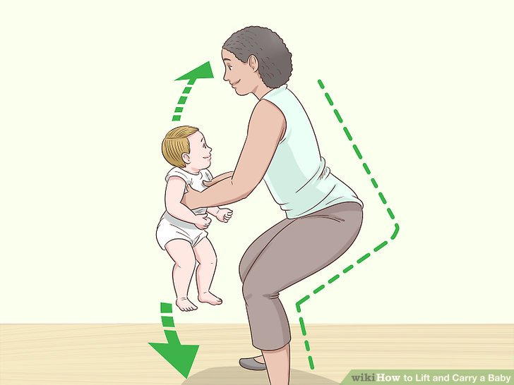
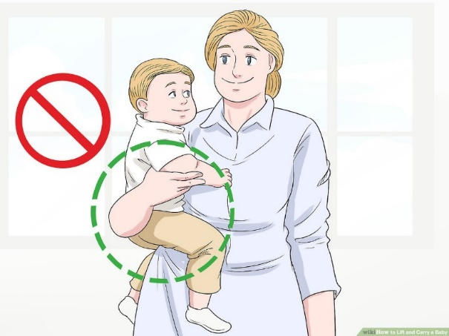
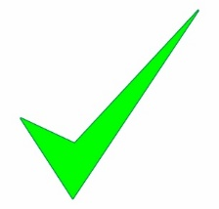

Risk Assessments
The following 5 steps illustrate the risk assessment process at the nursery:
- Identify the risk within my environment, equipment or practice.
- Decide who might be harmed and how.
- Evaluate the risks and decide on precautions.
- If action is required implement this
- Review my decision is the risk still there or is it resolved this is then shown through the signatures on the daily risk assessments.
The owner and manager review the annual premises risk assessment yearly to ensure that the premises are safe and maintained. The nursery carries out risk assessments on a daily basis in any area the children have access too.
An individual risk assessment may be required if a child or staff member has a specific care requirement: expectant mother, young person or specific care needs e.g. diabetes, etc.
The nursery has a Health and Safety Policy which includes procedures for identifying, reporting and dealing with accidents, hazards and faulty equipment.
Risk assessing outings
For any activity taking place off the nursery site, a specific risk assessment will be undertaken by the room leader. The risk assessment will detail where the outing is to and highlight the risks that could be possible. If major risks are found; the children will not attend the trip. Staff are responsible for assessing risks once they have arrived at the destination, if any risks are found that cannot be resolved/removed the children and staff will return to the nursery site.
To ensure safety of the children when outside the nurseries the children will be provided with:
- Fluorescent bibs
- Pushchairs
- Reins if requested by parent
All members of staff are suitably trained to support the children and the qualified members of staff will be first aid qualified. It is also our policy that at least one member of staff will have a mobile phone in case of any emergency, carry a first aid box and any medication the children may require.
Children will only be allowed on outings if parents/carers have signed a permission form/given verbal consent or signed on child information sheet but must be informed on or before the day of the trip. Snacks and refreshments will be provided as required by the nursery taking into account any allergies, etc.

COSHH
COSHH is the law that requires employers to control substances that are hazardous to health. We reduce workers exposure to hazardous substances by:
• finding out what the health hazards are;
• deciding how to prevent harm to health (risk assessment);
• providing control measures to reduce harm to health;
• making sure they are used appropriately;
• keeping all control measures in good working order;
• providing information, instruction and training for employees and others;
• providing monitoring and health surveillance in appropriate cases;
• planning for emergencies.
Tiny Robins day nursery uses substances such as floor cleaners, toilet cleaners, antibacterial cleaners (All BSEN coded) and products that are mixtures of substances such as Zuflora which is mixed using the directions on the bottle.
Sometimes substances are easily recognised as harmful. Common substances such as paint, bleach or dust from natural materials may also be harmful. Bleach is to be used by the cleaner when children are not present and to disinfect the bins on a Friday evening.
COSHH covers substances that are hazardous to health. Substances can take many forms and include:
chemicals, products containing chemicals, fumes, dusts, vapours, mists, nanotechnology, gases and asphyxiating gases and, biological agents (germs). If the packaging has any of the hazard symbols then it is classed as a hazardous substance, germs that cause diseases such as leptospirosis or legionnaires disease and germs used in laboratories
Any substances that fall under COSHH regulations are kept in the cleaning store within the Utility area (Hall way locked cupboards) to which children have no access. Staff are trained in the control of these cleaning products and ensure gloves and PPE are worn when in use. Substances are not used when children are in the building and are checked weekly by the manager.
All staff are required to complete a health and safety in the workplace course which includes COSHH via Noodle Now- Reviewed 3 yearly.

